

Computer Networks Lab(CSE 320)

Department of CSE

**Assignment**

|  |  |
| --- | --- |
| **Topic/Question:** | [Using Cisco Packet Tracer to simulate Smart Home System](https://www.researchgate.net/publication/338422167_Using_Cisco_Packet_Tracer_to_simulate_Smart_Home) |

Date of Submission: 2 Oct 2020

|  |  |
| --- | --- |
| Submitted by | Submitted to |
| Name: Niamul Hasan  Id: **17201026**  Semester: 3-2  Section: A1 | Dr. A S M Touhidul Hasan  Assistant Professor  UAP |

**Introduction:**

How a IOT based smart home system works? As we are the student of technical site, the answer of this question is important for us. Nowadays we can see this kind of system in use. People are using this kind of system to control their home appliance remotely from another place. In a IOT based smart home system, smart devices were in fact connected to IoT in order to simulate full components interaction and capability to remote control the devices. Home owner in fact, after connecting via browser and pass the authentication, was able to command garage door or the house ventilation but also check the current status of the alarm system or the level of carbon dioxide in the garage. In the report we will simulate Smart Home System using Cisco Packet Tracer.

**Network layout:**

This is going to be a very basic setup of a smart home system. Here, the network logically separated in three areas: home network, ISPs/Internet and corporate office network.

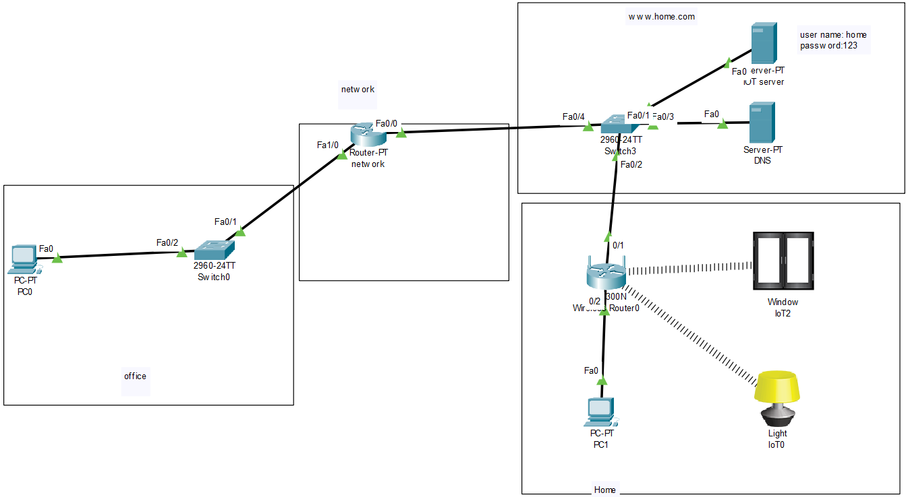

In this system, the window and the light remotely be controlled from the office network and inside the house as well.

Here PC0 is a PC in office network (192.168.1.0) and PC1 is a PC in home network (192.168.0.0).

**Configuration:**Now, here we will see the steps to configure the network:

1. At first, take all the elements properly and connect them through appropriate wires (except the light and window).
2. Now, setup the home Wi-Fi router with IOT server.

To do that, IOT server and home Wi-Fi router should be in same network (192.168.0.0) and make the home Wi-Fi router as default gateway for IOT server.  
Save the settings.

|  |  |
| --- | --- |
| IOT server | Home wife router |
|  |  |

1. Inside home wife router at GUI tab, set SSID as “Home”.  
   After that go to Wireless Security sub tab to set security mode to WPA2 Enterprize and set RADIUS port to the IOT server’s IP address (192.168.0.10). Save the settings.

By this we are making the IOT server as the controller of the system.

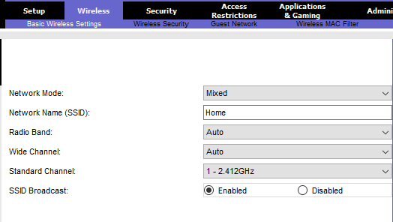

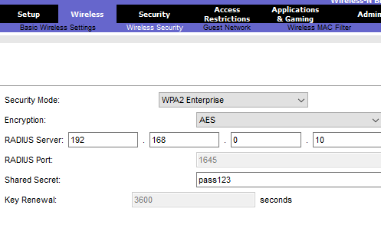

1. Now, setup IOT server services🡪 AAA

Here, we make the home Wi-Fi router as client and give every home appliance a user name and a password. Make the service on.

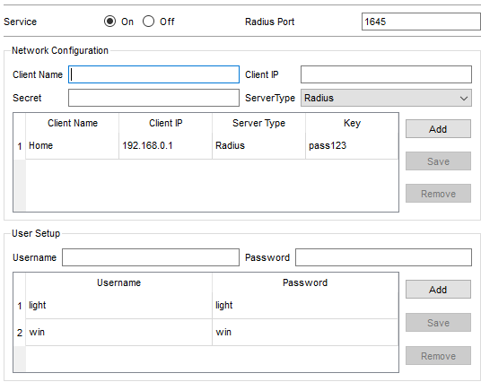

Make IOT services on.

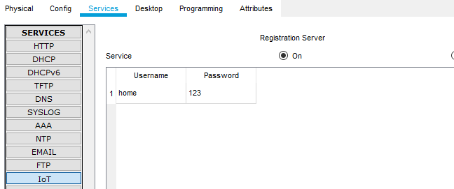

1. Now for light and window:

Inside the Wireless0 settings, set SSID as “Home”.

WAP2:

|  |  |
| --- | --- |
| For light | For window |
|  |  |

1. Set the IP address for office PC (192.168.1.2) and home PC (192.168.1.2).

Set network router IP addresses and routing.

Now access the IOT server (192.168.0.10) from the browse of any of the PCs.

Now, sign up by clicking the sign up now.  
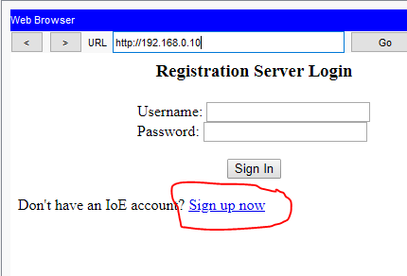

Example of signup user name and password: home, 123

1. Now inside light and window, configure tab:

|  |  |
| --- | --- |
| For light | For Window |
|  |  |

1. Now, we can access the IOT server by the IP address (192.168.0.10). By signing in we can control the light and window.
2. We can setup the DNS server to access the IOT server by a domain name (optional).

**Conclusion:**

From the simulation we can understand the basic setup of a smart home system.

For future work we can add internet cloud between this system and see how it works.

We also can add more routers in this system to understand the overall scenario better.